Kylee Reuther
EDU 413 01: Community/Parent/Teacher/Child Relationships
April 29, 2016

Enchanted
Welcome to Enchanted preschool where we treat your wonderful princes and princesses as royalty. I am so excited to have your child in my classroom this year. I look forward to building a relationship with both you and your child this year. I have put together a few things that you might find helpful on the topics of: parenting, communicating, learning at home, volunteering, decision making, and collaborating with our community. If you have any questions or concerns about your child’s education please do not hesitate to come to me and I will do my absolute best to help you. Thank you for taking the time to look over these. Lets have a wonderful year together!!

Communicating
What is it?
This is a conference agenda. It is a preschool “report card.” Also, I made a parent teacher conference reminder.
Why did I choose it?
This is a perfect communication visual for both the parents and I when they come in for parent teacher conferences. I chose to do make a parent teacher conference reminder to remind parents that they have a meeting coming up with me because during their busy lives meetings that only happen a few times out of the year can easily be forgotten if they are not reminded of them.
How am I going to use it?
All of the things in the document will be everything that I would cover during my conference with the parents. Before parents would come in I would have all students tested on all areas covered in the conference agenda. Also, I have made a reminder of parent teacher conferences for students to take home to their parents. This is something I plan to use in my future preschool someday.

Uppercase Letter Recognition
Enchanted Conference Agenda

--If your child has mastered the letter there will be star in the box. If your child attempts the letter but does not say the correct sound the sound he or she says will be marked in the box. If your child does not know the sound at all (no attempt) and x will be marked in the box.

A | B | C | D | E | F | G
H | I | J | K | L | M | N
O | P | Q | R | S | T | U
V | W | X | Y | Z

Rhyming
- I will ask your child what rhymes with the words below and record what they believe rhymes with the word.

Cat Bow

Tan Big

Opposites
- I will ask your child what tis the opposite of the following words below and record what they believe rhymes with the word.

Hot Up

New Boy
Numeral Recognition
--If your child has mastered the number there will be star in the box. If your child attempts the number but does not say the correct number the number he or she says will be marked in the box. If your child does not know the number at all (no attempt) and x will be marked in the box.

3 | 5 | 0 | 1 | 4 | 2
7 | 9 | 8 | 6 | 10
Counting Objects Rote Counting (0-50)
0-15

6-10

Colors

Red
Orange
Yellow
Green
Blue
Purple
Black
White
Brown
Pink
Gray

Shapes

Conference Reminder
__________________’s
Parent Teacher Conference is
scheduled for
____________ at ________.
If you are unable to attend,
please contact me ASAP. I look
forward to meeting with you!

Decision Making
What is it?
A letter inviting parents to attend a meeting to discuss their preschooler’s education with me and other preschool parents.
Why did I choose it?
I chose this because it is a good way for me to hear parents’ opinions on their child’s education. By having this be a collaborative meeting with other parents I hope to make this more of an open conversation so that parents are not discouraged to share what is on their mind. Also, I would make a survey on survey monkey for parents discuss their topics on their child’s education if they are not able to attend the meeting.
How am I going to use it?
I will use this every year in the classroom around December 1st so that during Christmas break I can plan my curriculum while taking any concerns from parents into considerations. At the end of the year I would want to send out a link for parents to share and recommendations they have fore next years preschool curriculum or anything that they were not satisfied with so I can change it for the next year.
New Year New Ideas!

It is crazy to think that this school year is already half over and that Christmas is right around the corner. I am always interested in what you as experts of your children have to say about your child’s learning. I would like to invite you to attend this meeting to discuss what you do or do not like so far about what is happening in your child’s preschool. Please be respectful and courtesy when voicing your concerns, as I will do the same when listening to what you have to say.

When: December 1st at 6:00PM

Where: Enchanted

Possible Topics:
- Does your child enjoy preschool? Why or why not?
- What is your child interested in?
- How do you feel our communication is?
- Field trips that you think would be worth attending
- What are some things you would like to see your child learning?
- What are some things that you feel your child is struggling with?

If you are unable to attend this meeting please scan the QR code or log on to the website to voice your concerns please.

Website: ***************************************************************

QR Code
I truly do appreciate and take in your concerns for consideration to the curriculum. Thank you for all of your support!

Learning at Home
What is it?
Task boxes that students can take home
Why did I choose it?
I chose to have home task boxes for students are able to take home and work with their parents. Because some families are unable to afford educational materials at home take home task boxes only require the parents’ time with their child. I hope to have parents realize what their child is and is not struggling with in my preschool classroom.
How am I going to use it?
I plan to have students take this home once a week and complete the task with their parents. I would have a sign out sheet and a form that parents must fill out if anything is missing or gets damaged. Also, I would want to provide a feedback form for parents to fill out telling me how their child did with the task. By having parents tell me how their child did with the task I can create my curriculum around things that students are struggling with while at preschool.

Take Home Task Boxes
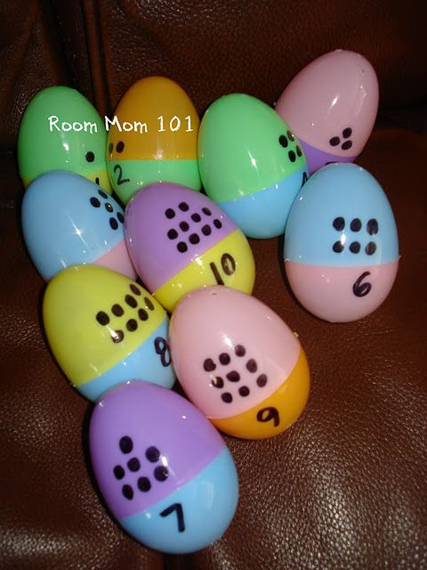
Number Egg Matching
- MTH 1.4 Demonstrates understanding of one-to-one correspondence between objects and numbers
- Students will be able to take home plastic eggs that have a number of dots on one side and on the other side will have a number. Students will have to match the correct number of dots with the correct number. Parents will be able to see how well their child is able to match the numerical number with the correct number of dots.
Materials:
- Plastic Eggs
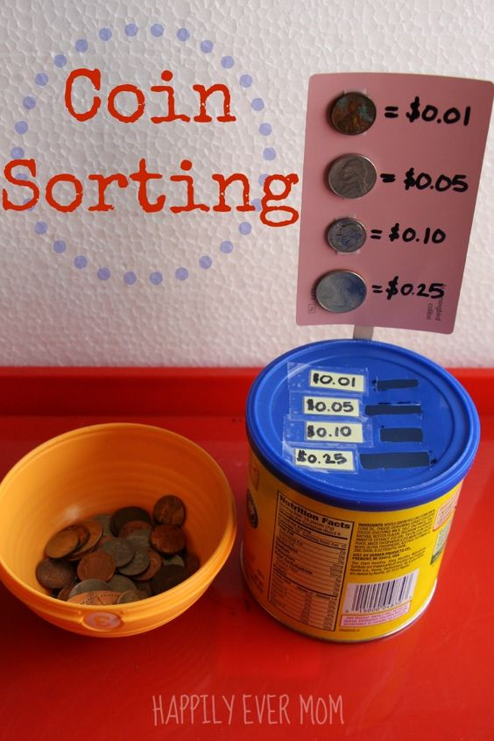
Coin Sorting
- SS 3.1 Know that people perform various kinds of work to earn money to buy things they need.
- Students will have to sort the coins in a container. Students will discuss things that they can buy and why they need money.
Materials:
- Coins
- Coin container sorter

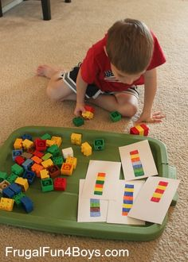
Lego Patterns
- MTH 2.3 Recognize, duplicate, and extend simple patterns of objects, sounds, and movements using manipulatives
- Students will have to make patterns that match a picture with Legos. They will be encouraged to make their own patterns using the Legos provided.

Materials:
- Legos
- Pattern sheets
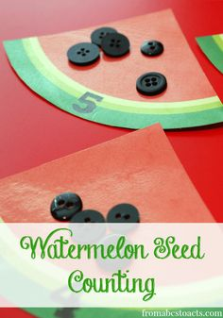
Watermelon Seed Counting
- MTH 1.4 Demonstrates understanding of one-to-one correspondence between objects and numbers
- Students will have to count the number of black buttons to match the numbers of black seeds inside the watermelons provided
Materials:
- Watermelon cutouts
- Black buttons

Volunteering
What is it?
Volunteer sign up sheet
Why did I choose it?
I chose to make this for my future preschool for parents to sign up for things that they are interested in volunteering for to help their child’s classroom out with. When I have an idea of when parents are available and what they are interested in helping with in the classroom I will be able to know when I will be able to get help and when I will not be able to get help.
How am I going to use it?
I will use this in my future preschool at the beginning of the year so that I have an idea of which parents want to help out with specific things in the classroom. When I know that there is an area that I will need more people in I will recruit more people that may involve aunts or uncles if I need to.

We L VE having helpers in the classroom!
We adore having parents, guardians, and grandparents in the classroom to help us with projects, field trips, and many more things. If you are able to help us out during the school year please fill out the form below.

Name_______________________ Phone Number ____________
Student’s Name _______________________________________
Email Address ________________________________________

I am available: AM PM Both

Monday Tuesday Wednesday Thursday Friday

_______ I cannot come to school, but I can help at home. Please send home things for me to do.

Things I would be interested in helping with:

_____ Reading to Students
_____ Chaperoning field trips
_____ Small group teaching
_____ Party food preparation

_____ Party decorating
_____ Laminating/cutting
_____ Assisting with projects
_____ One on one tutoring students

Comments ______________________________________________________________________________________________________________________________________________________________________________________________________________________________________________________________________________________________________________________________________________
Parenting
What is it?
QR codes that can be scanned to take parents to articles that have various topics about child development
Why did I choose it?
QR codes seem to be something that is very popular in the education world today. I wanted to create a document that would be up to date with technologies in the present generation. QR codes can be easily accessible for most people who have a QR code scanner on their cell phone, which is a very high percentage of upcoming parents.
How am I going to use it?
I probably will not use these articles in my future preschool because things are always changing so I will want to update the article and QR codes. I plan to give something similar to this out to the parents in my preschool. I think this is a better way to have parents read up on material rather than handing them articles or brochures because this way they can choose which topics sound interesting to read about.

Child Development Articles on NAEYC Website

Help Your Child Build Fine Motor Skills
How to Support Children’s Approaches to Learning? Play with Them!
Help Your Preschooler gain Self- Control

Big Jobs at Home
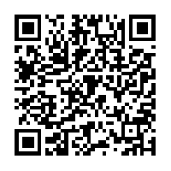
Why This Toy?
Encouraging Healthy Sleep Habits
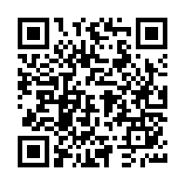

Listen, Talk, Answer-Support Your Child’s Learning
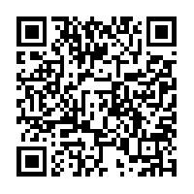
Help Your Child Become a Great problem Solver
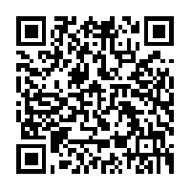
Collaborating with Community
What is it?
Summer camp at the preschool with a farm theme
Why did I choose it?
I chose this because I think this is a great way to get children excited about learning. It gives them something to do during the summer rather than sitting on the couch with their Ipad. Farming is a big thing in North Dakota, so I thought it would be a great way for students to experience and understand some elements that go into farming.
How am I going to use it?
I am so excited to use this idea for a camp in the summer. It will be a great way to get my name out as a good preschool and it is one way I can still make a little extra cash during the summer, but still have my summers off. I hope to have a themed summer camp each month if students seem to be coming. By having it open to the community children are able to bring their friends that may go to another preschool during the school year.
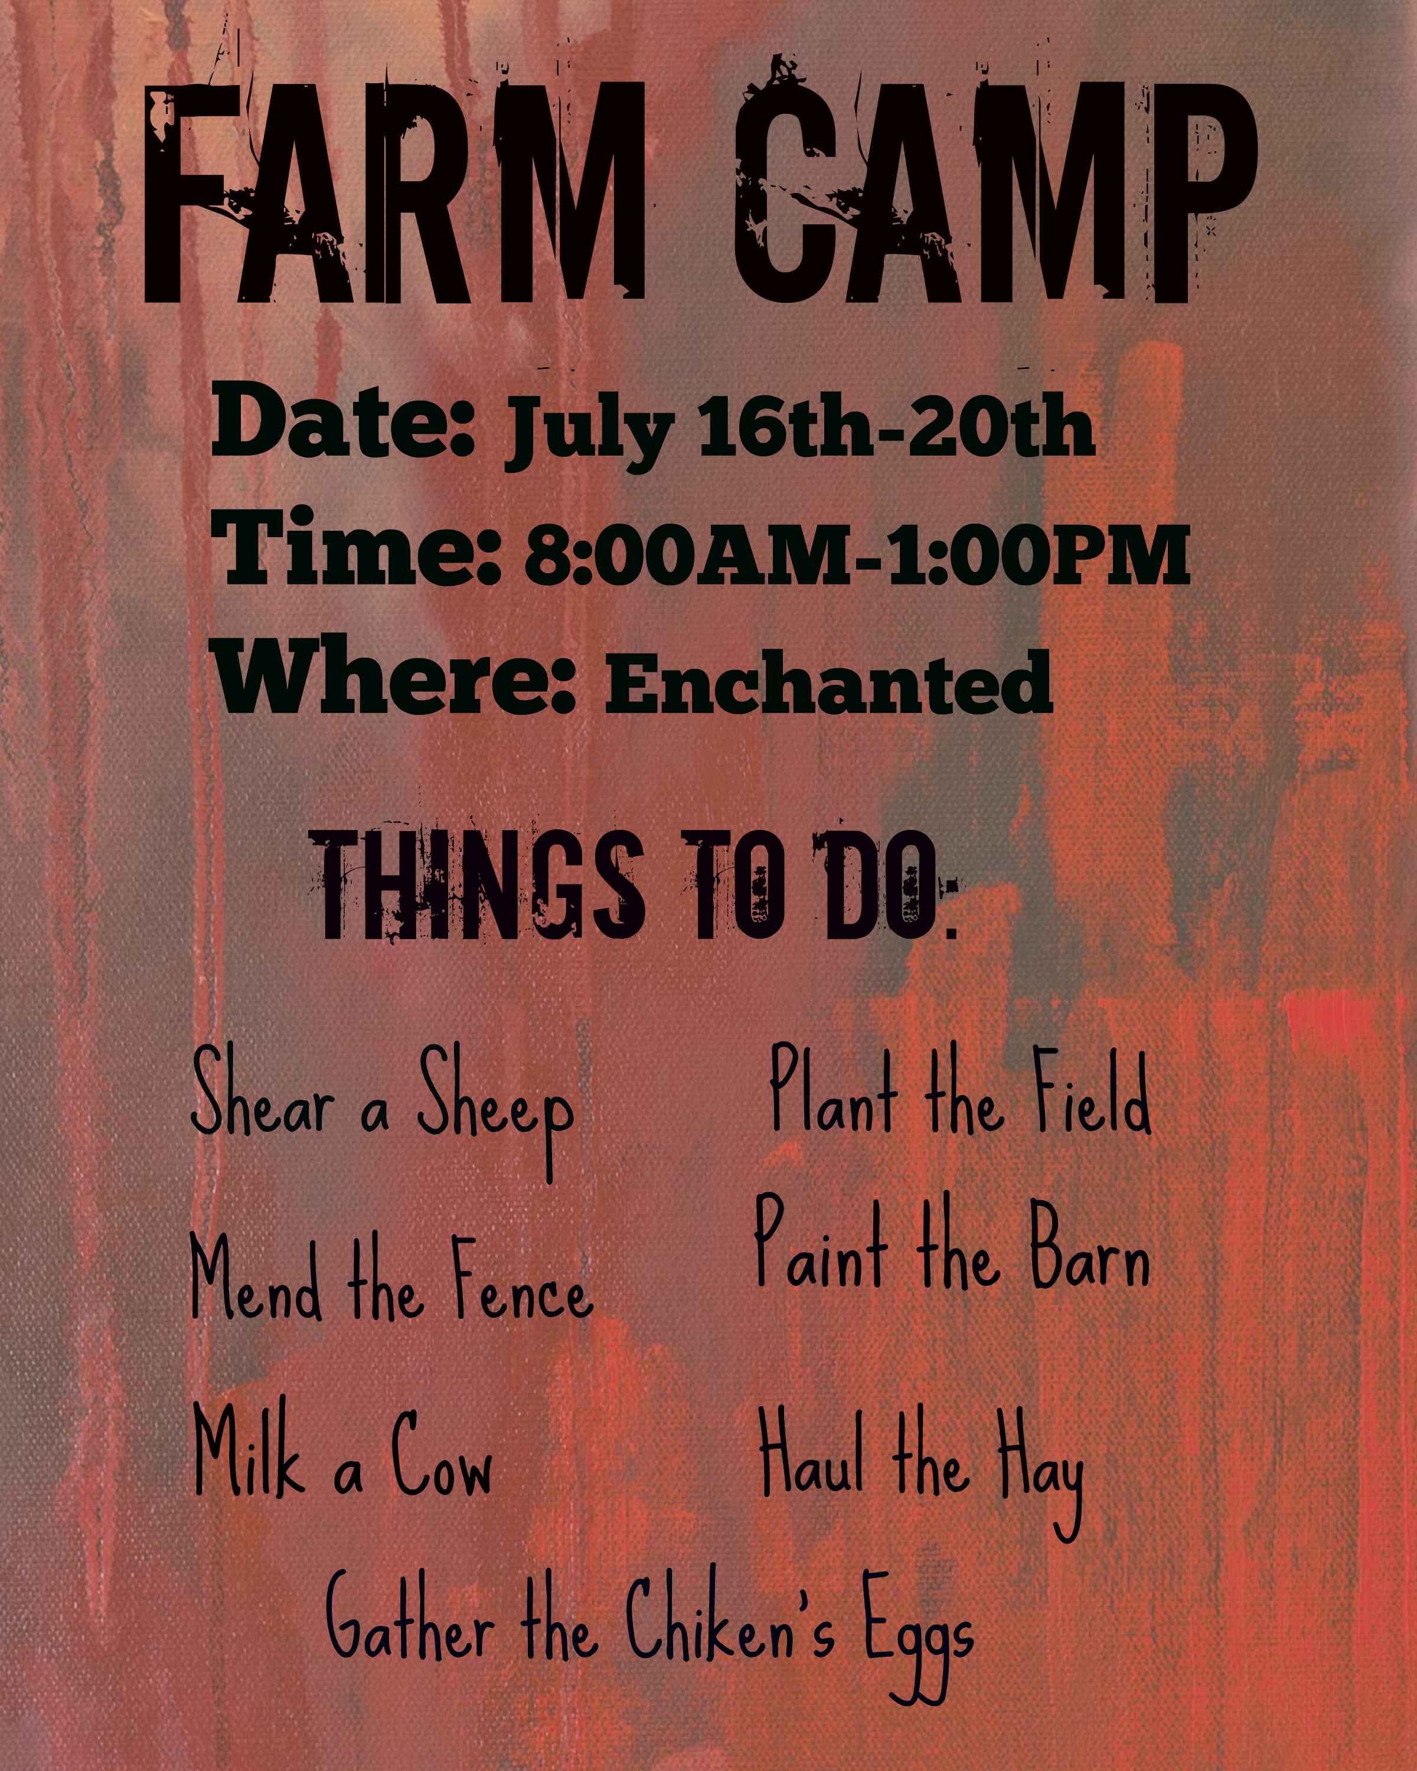

Works Cited
http://schools.nyc.gov/NR/rdonlyres/9B93B5B0-9F75-463D-9BCF-
http://krazyforkindergarten.blogspot.com/2011/04/farm-day-2011.html
http://www.picmonkey.com/#edit
https://www.pinterest.com/pin/560135272383897218/
https://www.nd.gov/dpi/uploads/155/NDprekconstandards.pdf
https://www.pinterest.com/pin/393150242447284923/
https://www.pinterest.com/pin/393150242451515804/
https://www.pinterest.com/pin/393150242447284979/
https://www.pinterest.com/pin/393150242451515958/
https://www.pinterest.com/pin/393150242451515959/
http://families.naeyc.org/learning-and-development/child-development-view
http://www.qrstuff.com

