Healthy Food Math
Grade Level: First Grade
Subject Area: Physical Education and Mathematics
Materials Needed: Life size plus, minus, and equal sign, Teeth chart, Paper healthy and unhealthy food, Story problems, Binders, White board markers, The Berenstain Bears Visit the Dentist book, Tape

Standards
- S3.E6.1 Assessment & Program Planning Nutrition- Differentiates between healthy and unhealthy foods.
Objectives
- Construct a list food that is good and bad for their teeth
- Identify the question in a story problem
- Solve a single digit subtraction or addition story problem by drawing out the specific items.
Learning Activities
- 9:30am – 9:40am
  - Students will listen to the story “The Berenstain Bears visit the Dentist”
- 9:40 am-10:00am
  - Binders
    - I will explain what we will be doing
      - “Everyone will be given a binder each binder has 9 story problems in them. We are going to solve each story problem together.”
      - Read the story problem
      - Underline the question
      - Circle numbers
      - Box keywords
        - Go over the key words for addition and subtraction
      - Draw pictures to solve the problem
    - Each student will receive a binder with 9 single digit story problems (addition and subtraction). I will pull up the story problem we are working in front of the class so students can follow along with me.
    - Once we have solved the problem the student(s) who is helping me will grab the number of food items in the story problem and will put it on the correct tooth to indicate whether it is good for our teeth or bad.
    - When all story problems are complete we will count how many food items we had on each tooth all together.
    - On the last page in their binder they will write down three things that are good for their teeth-sound out the word(s).

Assessment
- Informal: I will observe whether or not students can underline the question in the story problem.
- Informal: I will observe whether or not students can circle the numbers in the story problems.
- Informal: I will identify if students know what food items are good for their teeth and which ones are not.
- Formal: Students will be given a quiz
  - Will include and addition and subtraction story problem. They must underline the question, circle the numbers, box key words, and solve while showing their work.
  - Also, will need to list 3 food items that are good for their teeth and 3 food items that are not.
Reflection

Charts to go along with the lesson:
Words inside addition sign:
- Together
- Plus
- Combined
- Increase
- Add
- Both
- Total
- In all
- Sum
- Altogether

Words inside subtraction sign:
- Difference
- Fewer than
- Need to
- Fewer
- How many more
- How much more
- Minus
- Take away
- Less than
- Subtract decrease

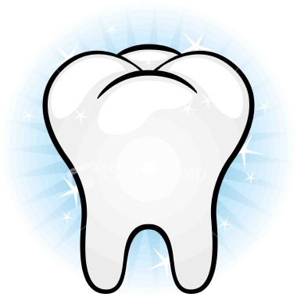I will have two teeth made out of poster board label good and bad for students to stick which foods are good for the teeth and bad.

- Jane had 6 strawberries and Mark and 4 strawberries? How many strawberries did they have all together?

- Dan had 7 pears and Jake gave him 1 pear. How many pears does Dan have combined?

- Julie has 2 popsicles and Jack has 8 popsicles. How many popsicles do they have total?

- Sarah had 10 pieces of corn and John had 6 pieces of corn. How much more corn did Sarah have then John?
- Travis ate 5 ice cream cones and Karmen ate 5 ice cream cones. How many ice cream cones did Travis and Karmen eat together?

- Bob ate 3 bananas yesterday and 4 bananas today. How many bananas did he eat all together?
- Zach had 2 apples and Judy had 2 apples. How many apples did they have altogether?

- Dylan has 8 gummy bears, but 4 gummy bears fell on the ground. How many gummy bears does Dylan have left?

- Kevin’s mom gave him 10 peppers. He only ate 3 for lunch. How many more peppers does Kevin need to eat so there are no peppers left?

List 3 healthy foods that are good for your teeth:

1.

2.

3.

