Inside Out Emotions Game
Grade Level: Pre-School
Subject: Social Emotional
Materials Needed: pictures of characters, board game, game markers, dice, tape

Standards
- SED.1.3 Show increasing ability to regulate and communicate own feelings and emotions
Objectives
- Identify emotions
- Describe a time the felt a specific emotion
- Compare there game marker to others
- Recognize colors
Learning Activities
- Each player will take turns rolling the game die and moving their game pieces on the board accordingly
- Once a player lands on a space on the game board, they should locate the coordinating character picture and act out the emotion
  - For example: if a player lands on the yellow space on the board they will grab the Joy picture and act joyful
- (Optional) after acting out the emotion player can share a moment that he or she felt that emotion
- The orange space with the yellow circle represents a core memory. If a player lands on that space they should share one of their favorite memories.

Reflective Questions
  - What makes you happy?
  - What makes you angry?
  - What makes you sad?
  - What makes you annoyed?
  - What makes you scared?
  - What is you favorite memory?
  - What is your least favorite memory?
Vocabulary
  - Anger
  - Joyful
  - Disgust
  - Fear
  - Sadness
Assessment
- Students will be assessed by observation of how well they are able to recognize and describe emotions.
Reflection
This game was such a hit with the children. They really got into acting and sharing their emotions. The only thing that I would do different is laminate the colored dots when putting them on a die so it doesn’t get ruined and making the board game larger.

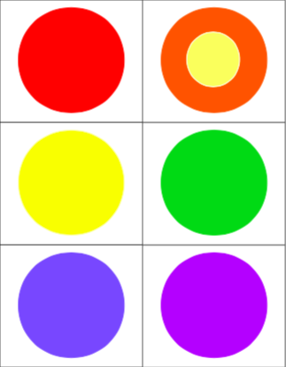

Inside Out Emotions Board Game

Materials
- Inside Out Movie (not provided)
- Inside out pictures of characters
  - Could also buy actual figures from Wal-Mart
- Inside Out board game
- Game markers (not provided)
- Foam or block dice (not provided)
- Tape (not provided)

Directions
- (Optional) Watch Inside Out movie
- Cut out colored dots and tape on dice
- Place character pictures next to the board game
How to play Inside Out Emotions Board Game
- Each player will take turns rolling the game die and moving their game pieces on the board accordingly
- Once a player lands on a space on the game board, they should locate the coordinating character picture and act out the emotion
  - For example: if a player lands on the yellow space on the board they will grab the Joy picture and act joyful
- (Optional) after acting out the emotion player can share a moment that he or she felt that emotion
- The orange space with the yellow circle represents a core memory. If a player lands on that space they should share one of their favorite memories.

