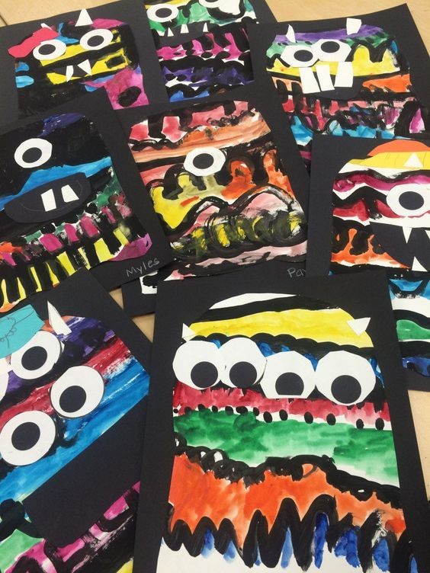
Line Monster Art
Grade Level: Kindergarten
Subject: Art
Materials needed: crayons, white paper, googly eyes, black semi circles, glue, black markers, pencils, white boards, whiteboard markers and erasers

Standards
- 4.1.2 Know the different techniques used to create visual art (line variation)
- 4.1.6 Use visual art materials and tools in a safe and responsible manner
Objectives
- Identify different types of lines
- Discuss their peers artwork
- Sketch different types of lines
- Construct an art piece made out of various lines and colors
- Choose something they like about a peers artwork
- Create a line monster
Learning Activities
- Read a the book A Bad Case of Stripes
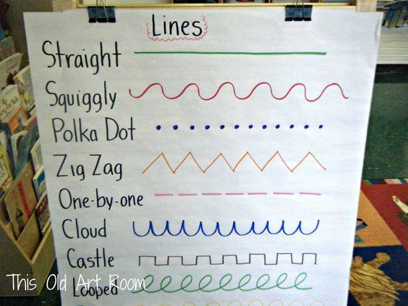
- Talk about the different kinds of lines
  - Show them the chart with various lines
    - Have students practice lines on a whiteboard
- Students will write their name on the back of their sheet
  - Teacher goes around and checks for names
- Explain to students they have to draw lines with their pencils
  - It can be ones that they see on the chart or they can use lines that are not on the chart
- After students have drew their lines with pencil they will trace over them with black markers
- Once students have black lines on their paper they can color in between each of the lines
  - Bring up what good coloring is again as a reminder to students
- After all coloring is done students can pick 1-3 googly eyes to use on place on their sheet
- Finally, students will take a black semi circle and draw teeth if they prefer and glue on the mouth
- Students clean up any mess they have made
- When students finish they can grab a book from their book box and draw the different lines that they find in their books on white boards
- If time allows have students do a an Art Walk
  - Students stand next to a picture say one thing they like about the art project in front of them
    - How many lines, colors, or eyes they used
    - Colors or lines they choose

Reflective Questions
- How did you draw that line?
- Why did you draw that line?
- Why did you pick those colors?
- What is your favorite line?
- What is your least favorite line?
- Do you have a name for your line monster?

Vocabulary
- Line
- Different kinds of lines
- Horizontal
- Vertical
- Diagonal
Assessment
- Students would be graded by their art project that they hand in.
  - Must have lines
  - Must have color
Reflection
  - I felt like this was one of my best lessons I have done. Students were very engaged the entire time. I had them watch me do a step than they would go back to their seats and do the step and every step they just came and sat and at the rug and watched me then they did it. This is something I would definitely use again teaching art. It would be a great Halloween art project. This lesson did get to be lengthy because so many children were taking their time and wanting it to be perfect. I would consider breaking this lesson up into 2-3 days rather than squeezing it all into one. Next time I would emphasize that the lines need to start at one end of the paper and finish on the opposite side because a few students did the lines but they were just short and didn’t touch either end of the papers which defeated the purpose of coloring in between the lines.

