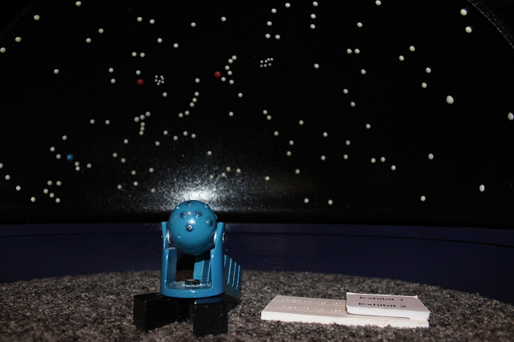
Starlab Language Arts Lesson
Grade: First and Second Grade
Subject: Language Arts
Materials: starlab dome with constellation cylinder, worksheet, pencils, black construction paper, glue sticks, stapler, table constellations groups, constellations myths and pictures, tape for the table name

Standards
- First Grade Standards:
  - W.3 Write narratives in which they recount two or more appropriately sequenced events, include some details regarding what happened, use temporal words to signal event order, and event, order, and provide some sense of closure
- Second Grade Standards:
  - W.3 Write narratives in which they recount a well-elaborated event or short sequence of events, include details to describe actions, thoughts, and feelings, use temporal words to signal event order, and provide a sense of closure.
Objectives
- Create their own constellation myth
- Know what constellations are
- Write using descriptive wording, ordered sequence, and use correct punctuation and spelling.
Learning Activities
- Preparation before:
  - Set up dome
  - Get chords and fan lined up
  - Check light bulb in projector
  - Get fan up and dome blown up
  - Have all materials in the gym:
    - Writing worksheet on Constellations
    - Students should have pencils and glue sticks
    - Have construction paper set out
    - Glue
    - Table Constellation groups
    - Stapler
    - Myths and pictures of the constellations in the dome
- REMIND STUDENTS THEY MUST BE QUIET (echoing) With the light on in the dome, have students make their way inside
  - Tell students it will be a little squishy but we need to all fit
- Reflective Questions
  - Does anyone know what constellations are?
  - What makes up constellations?
  - When can you see constellations?
  - Do you know of any constellations?
- Turn main light off and switch on projector
  - Remind students their eyes might take awhile to adjust to see the stars
- First point out the little dipper. Also known as The Little Bear
- Ask students if they know what myths are.
  - Myth- a traditional story usually involving people or supernatural beings such as bigfoot from the past
  - Read the small myth that goes with it
  - Ask students if the myth matches the picture they see of the constellation
- Point at the constellation of The Greater Dog also known as Canis Major
  - Ask students if they like hunting or dogs (raise hand) - which leads into the myth of The Greater Dog
  - Read the myth that goes along with The Greater Dog
  - Point out The Lesser Dog that goes along with the myth
- Point out Draco (The Dragon) constellation
  - Read the myth that goes with that
  - Turn light on again
  - Show class the pictures of Cadmus fighting the dragon and how the stars form the shape of the dragon
- Tell students that now we are going into the cafeteria and will be drawing and writing our own constellations in groups
- Have students slowly exit the dome
- Take all students into the cafeteria
- Tell what students are sitting at which constellation table
- After students are in groups and sitting by their worksheet and construction paper go over directions of the worksheet
  - Write both names on the worksheet
  - Come up with a constellation name
  - Draw your constellation
  - Go over items to include in your constellation myth/narrative
    - Must tell how the constellation represents the myth
    - Beginning, middle, and end to story
    - Descriptive wording
    - Punctuation and correct spelling
- Let students finish their myth worksheet and check with teachers
- Then their last step is to glue the sheets onto the construction paper
Assessment
- Rubric for Star Constellation Narrative Writing 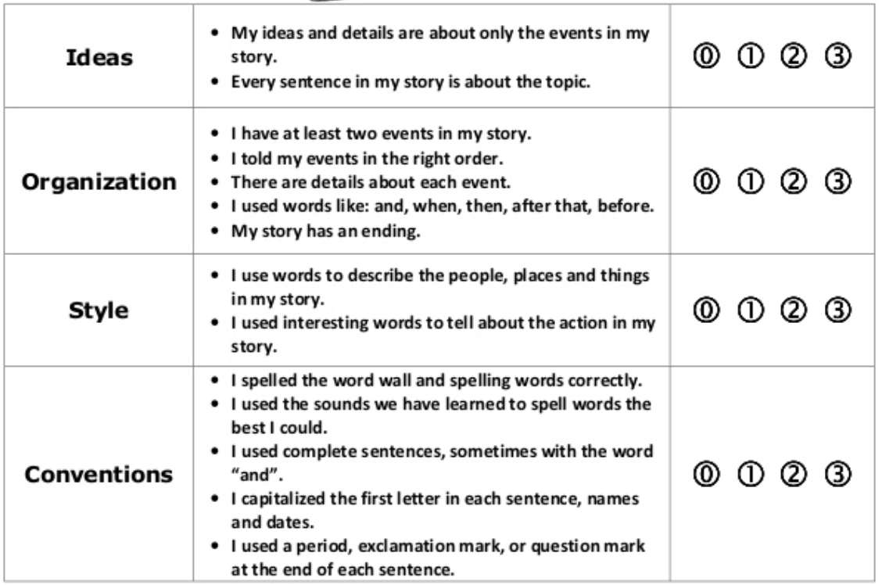
Reflection

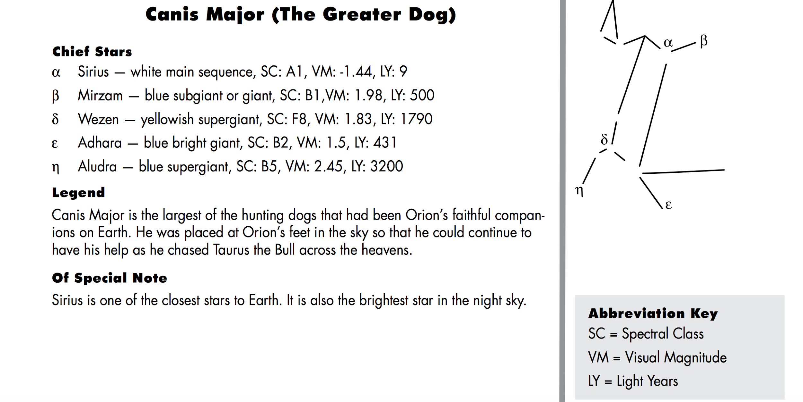
Canis Major - The Great Dog
Every hunter needs hunting dogs as companions and the Great Hunter Orion is no exception. Orion has two dogs as companions, Canis Major (the Great Dog) and Canis Minor (the lesser dog). Both of these faithful companions sit at the feet of Orion waiting for their next expedition.
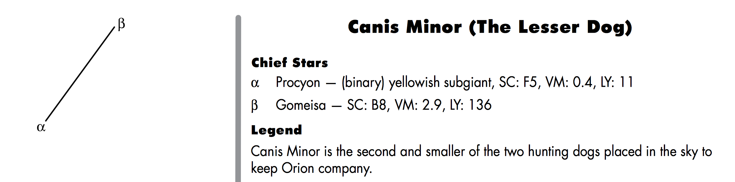
In addition to being one of the companions of Orion, Canis Major is also the stellar home of Sirius, which is the brightest star in the night sky. When Canis Major is visible, the brilliant white light of Sirius shines like a searchlight in the sky. Although Sirius is not a very large star, being only about one and one-half times as large as our own Sun, its young age and relatively close distance combine to make it so bright.
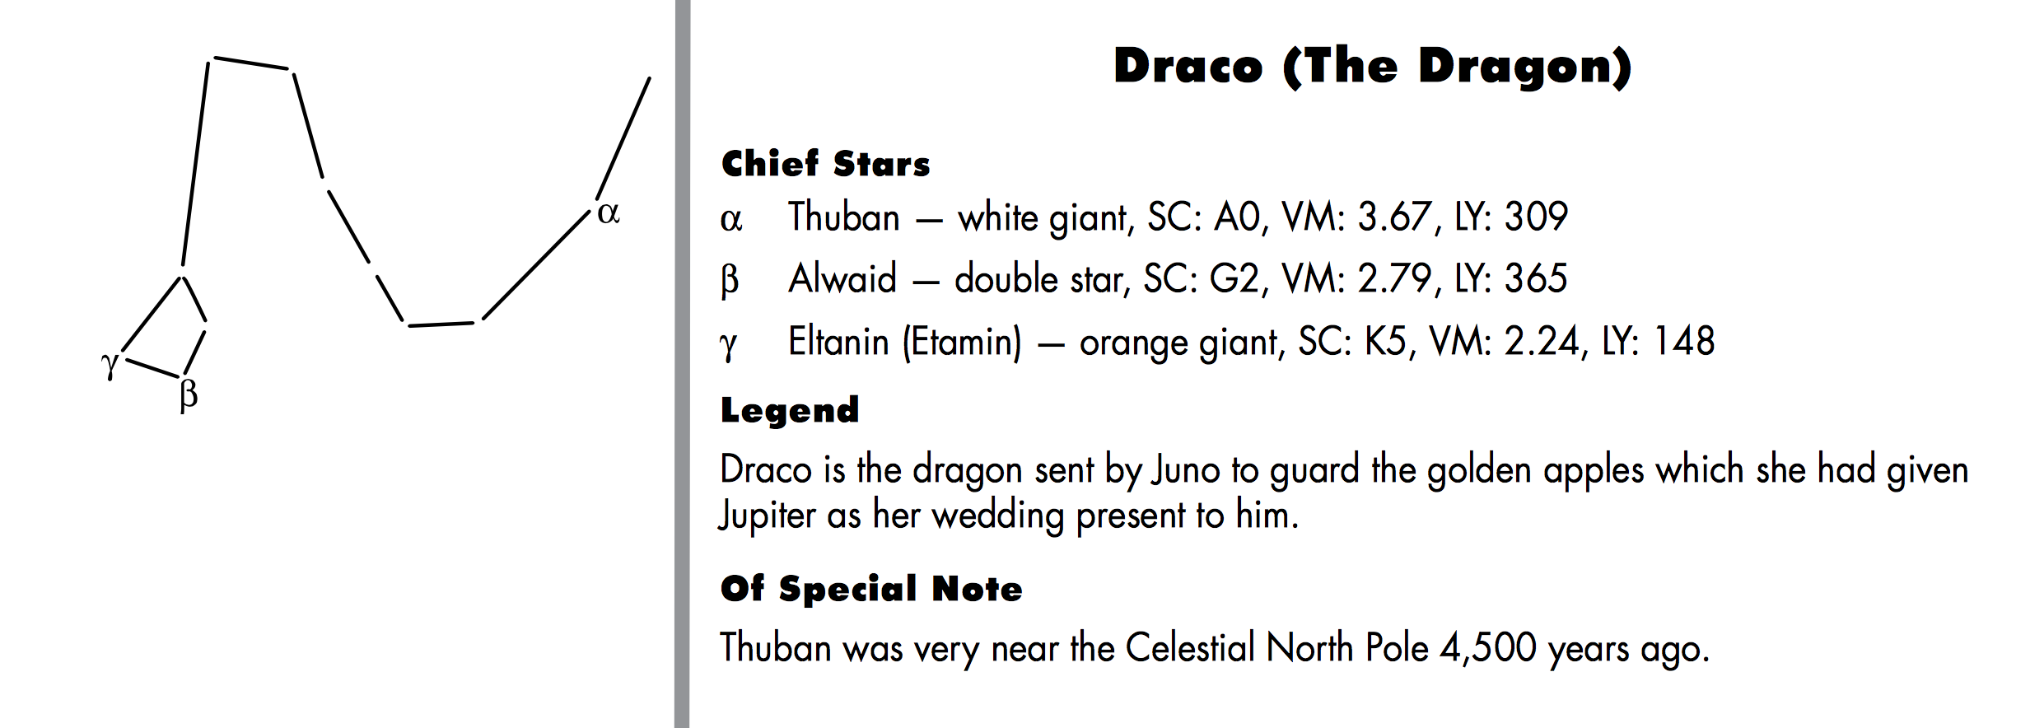
According to this story, Zeus had stolen the young woman from her home country. Her father ordered her brother, Cadmus, to go and search for her, and not return until he had found her and brought her back with him.

The brother, Cadmus, wandered over the whole world looking for his sister, but could not find her. He knew he would never find her because no one can find someone that Zeus has hidden. After not being able to find his sister, he wanted to build his own city.

While searching for water some of the brother’s friends were killed by a large dragon. Cadmus went to fight this dragon, and upon finding the dragon in a cave, was able to kill it with his spear. Cadmus was told to plant the dragon’s teeth in the ground.
Because Draco had been so faithful in guarding the caves and the teeth in the ground, Zeus placed his constellation in the northern sky, where, because his constellation never sets, he can guard all the treasures.
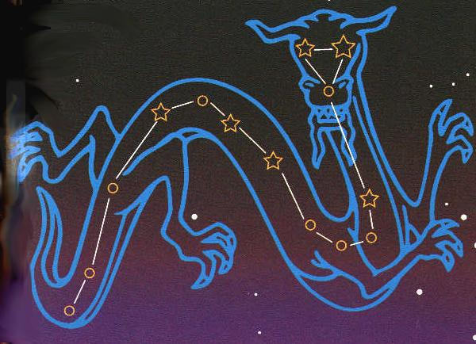

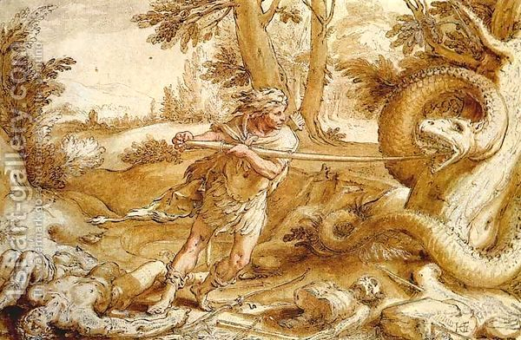
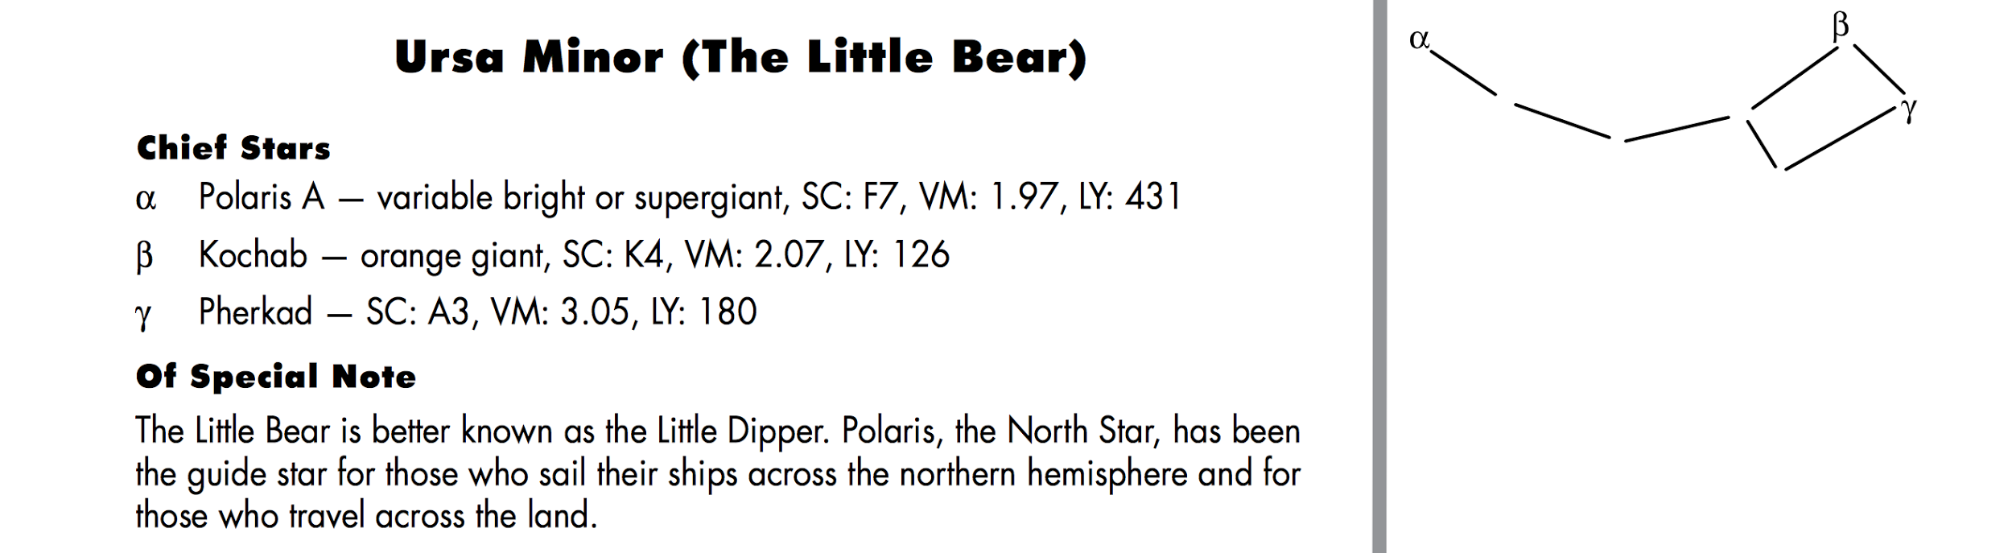

Constellation Partners
First Grade Second Grade
Jaymeson Conner
Chloe Rebecca
Caleb Ali
Bailee Ethan
Leticia Carter
Rayden Chastyn
Zaveyah Garrett
Hudson Mason
Titan/Kaliah Elliot
James G. Elizabeth
AShton Anna
Kristofer Cadence
Hassan Noah
Bella Bailey
Breanna Norah
Brady Jasmine
Gavin Kayla
James W. Justin

Create a Constellation
Names___________________________

Name Your Constellation ________________________________________
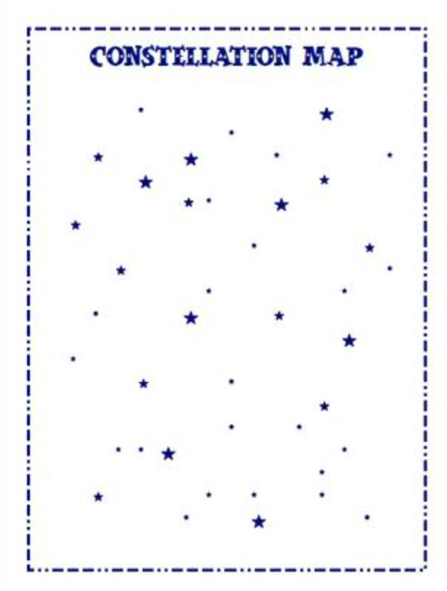
The myth of my constellation:
**Remember to include:
- Must tell how the constellation represents the myth
- Beginning, middle, and end to story
- Descriptive wording
- Punctuation and correct spelling

_______________________________________________________________

_______________________________________________________________

_______________________________________________________________

_______________________________________________________________

_______________________________________________________________

_______________________________________________________________

_______________________________________________________________

_______________________________________________________________

_______________________________________________________________

_______________________________________________________________

_______________________________________________________________

The Dragon Table

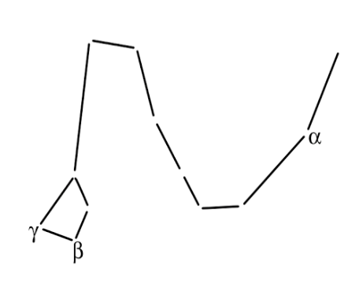

The Little Bear Table

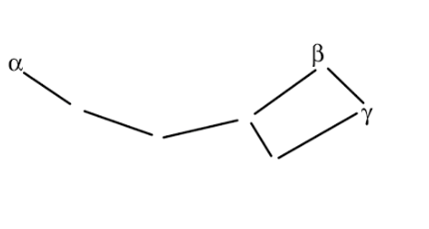

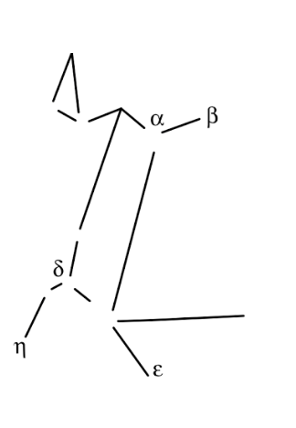
The Greater Dog Table

